DEPARTMENT OF PHYSICS
Department Activities Report (June 2023- March 2024)
Activity 1: Department of Physics organized an exhibition of the science projects prepared by the students on November 09, 2023. Different science based projects were displayed in the exhibition. Projects were prepared under the guidance of Dr. Manish Garg, Dr. Jasdeep Kaur, Dr. Mahesh kumar and Mr. Manpreet Singh of the Physics department.
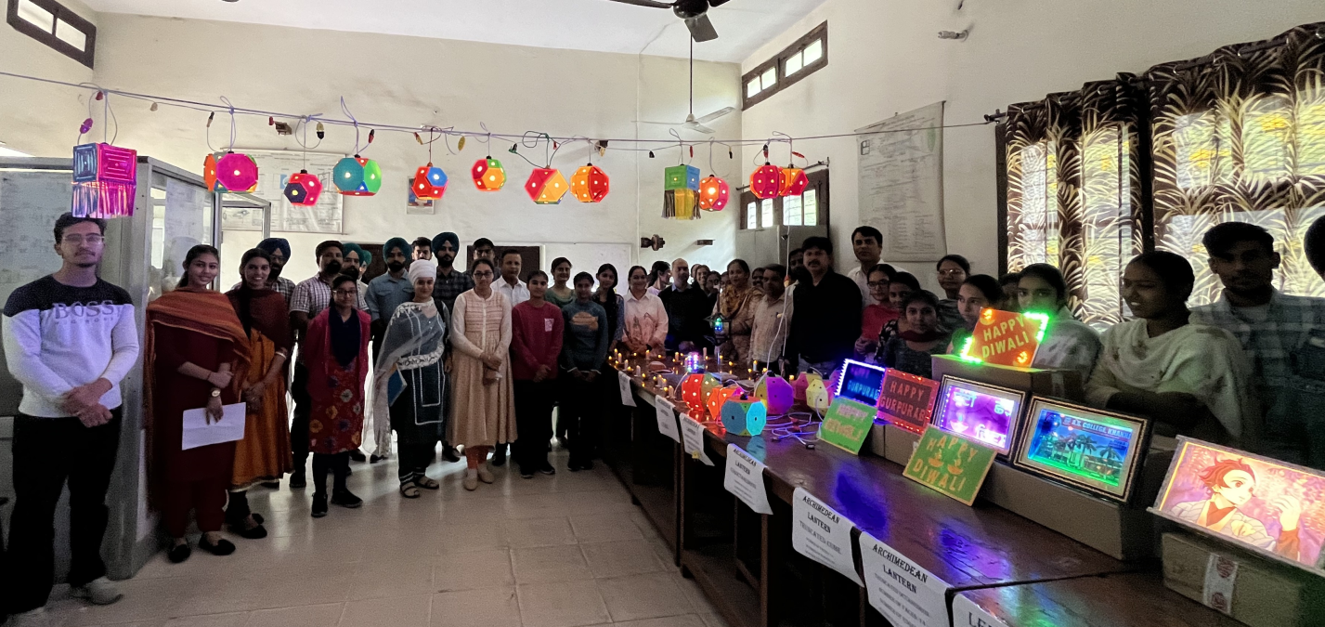
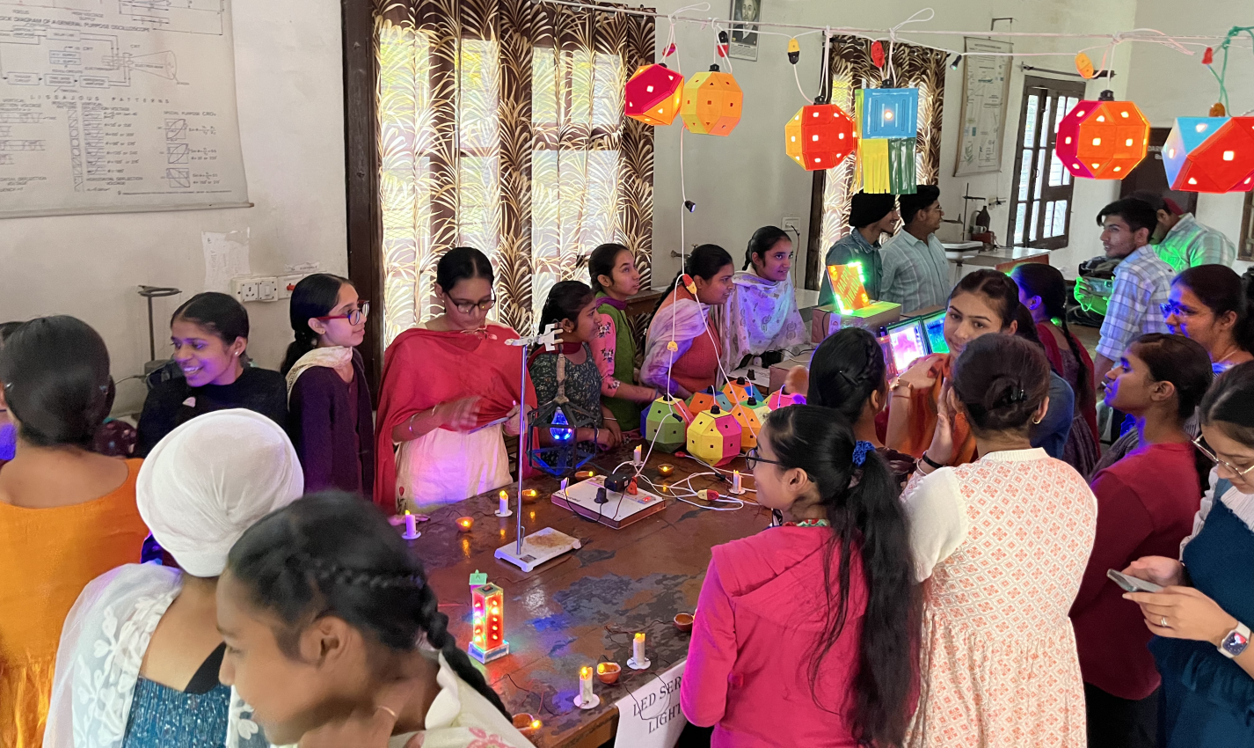
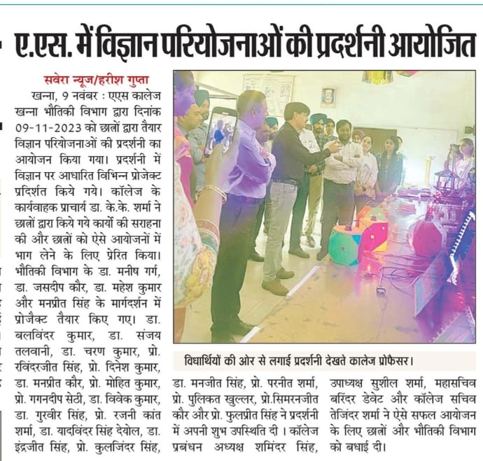

Activity 2: Physics Association organized a poster making competition on February 27, 2024. Around 40 teams of B.Sc. students participated in the event. Students made posters on the topics related to various subjects of science and technology. The competition was judged by Dr. Sanjay Talwani (Head, Biology) and Professor Ravinder Jeet Singh (Head, Chemistry) of the college. Team of Tejveer Kaur and Khushwinder Kaur of B.Sc. II stood first, Sakshi of B.Sc. II stood second and Team of Diksha and Sneha Chadha of B.Sc. I got third position in Poster Making competition.
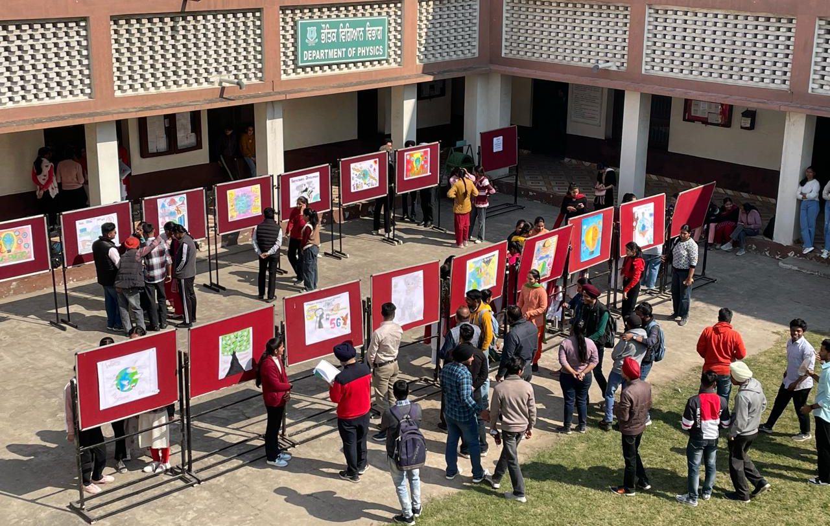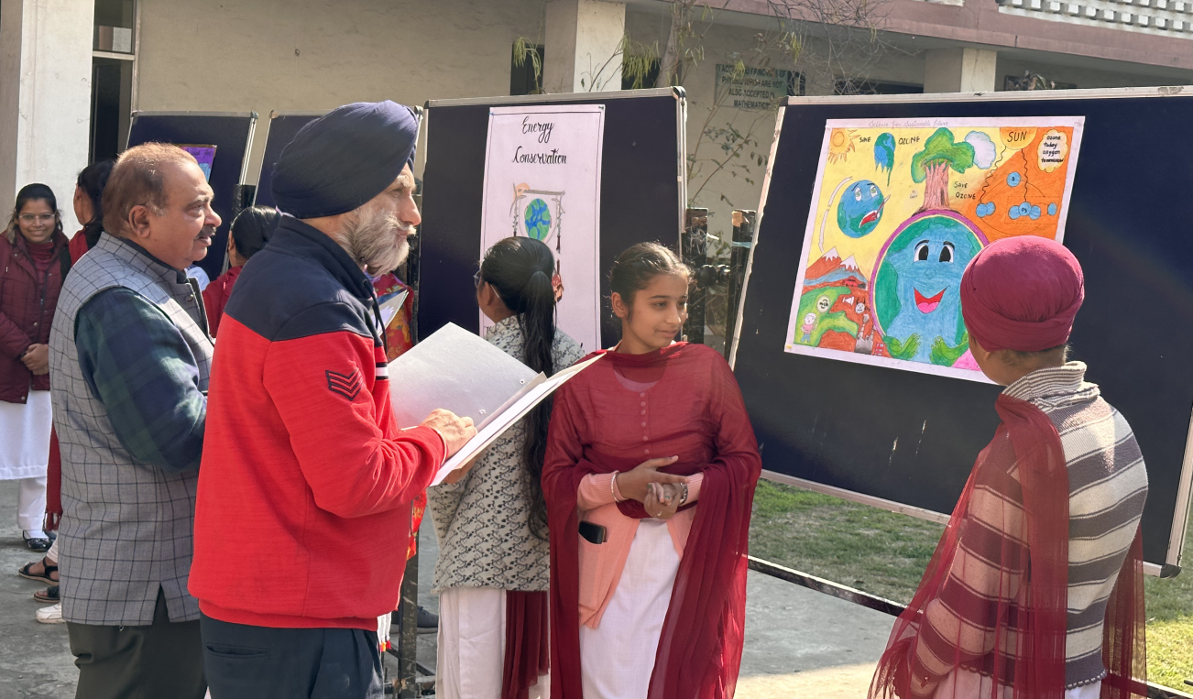
Activity 3: A power point presentation competition was organized by Physics Department to celebrate National Science Day on February 28, 2024. 25 students participated in this competition. The competition was judged by Dr. Charn Kumar (Head, Zoology) and Professor Ravinder Jeet Singh (Head, Chemistry) of the college. Gurbaksh Singh of B.Sc. III stood first, Harshpreet Kaur of B.Sc. III stood second and Kirti of B.Sc. I got third position in Power Point Presentation competition.
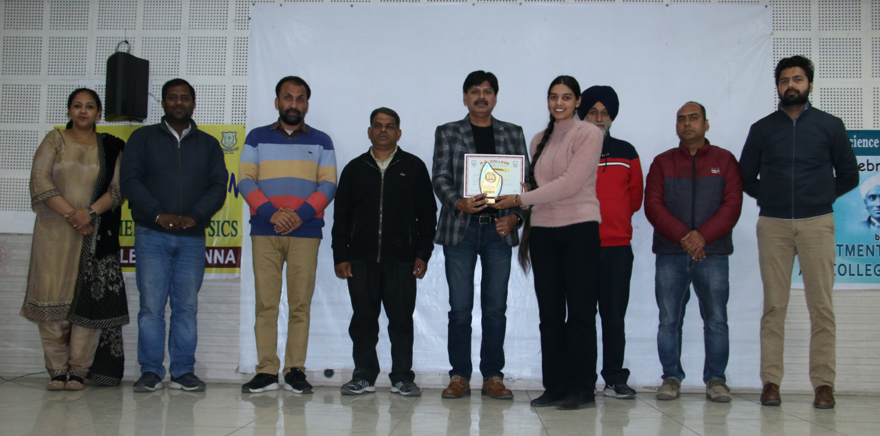

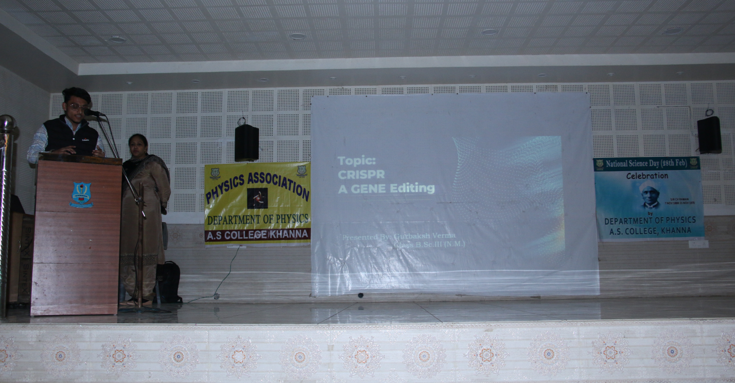

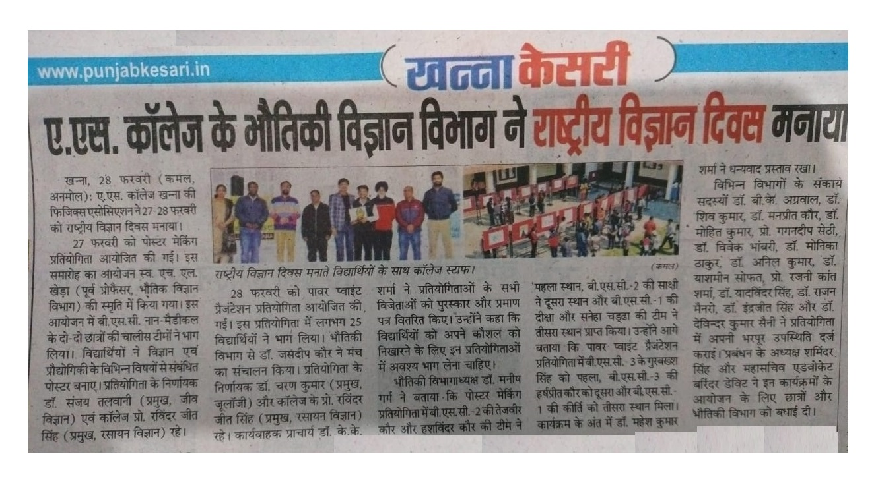
Activity 4: A lecture on “Significance of semiconductors in day to day life” in collaboration with Indira Gandhi National Open University, Regional centre Khanna was organized on March 13, 2024. The lecture was delivered by Dr. Manish Garg of the Physics department. Around 80 students of the college attended this programme.
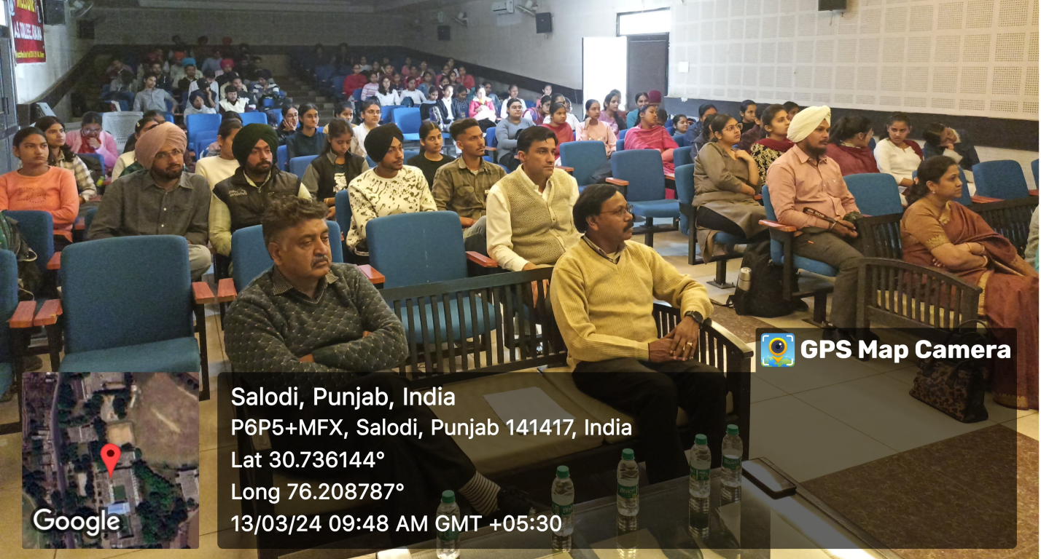

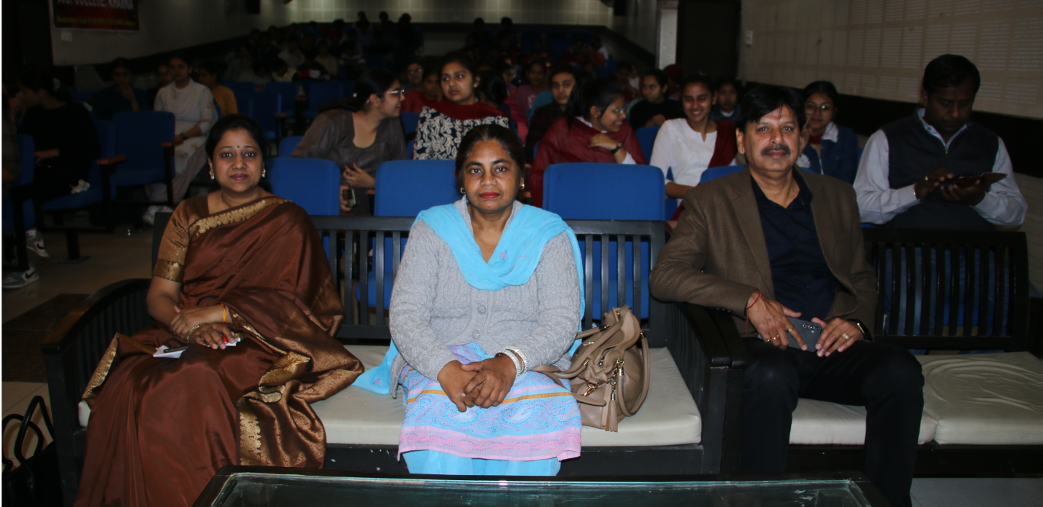

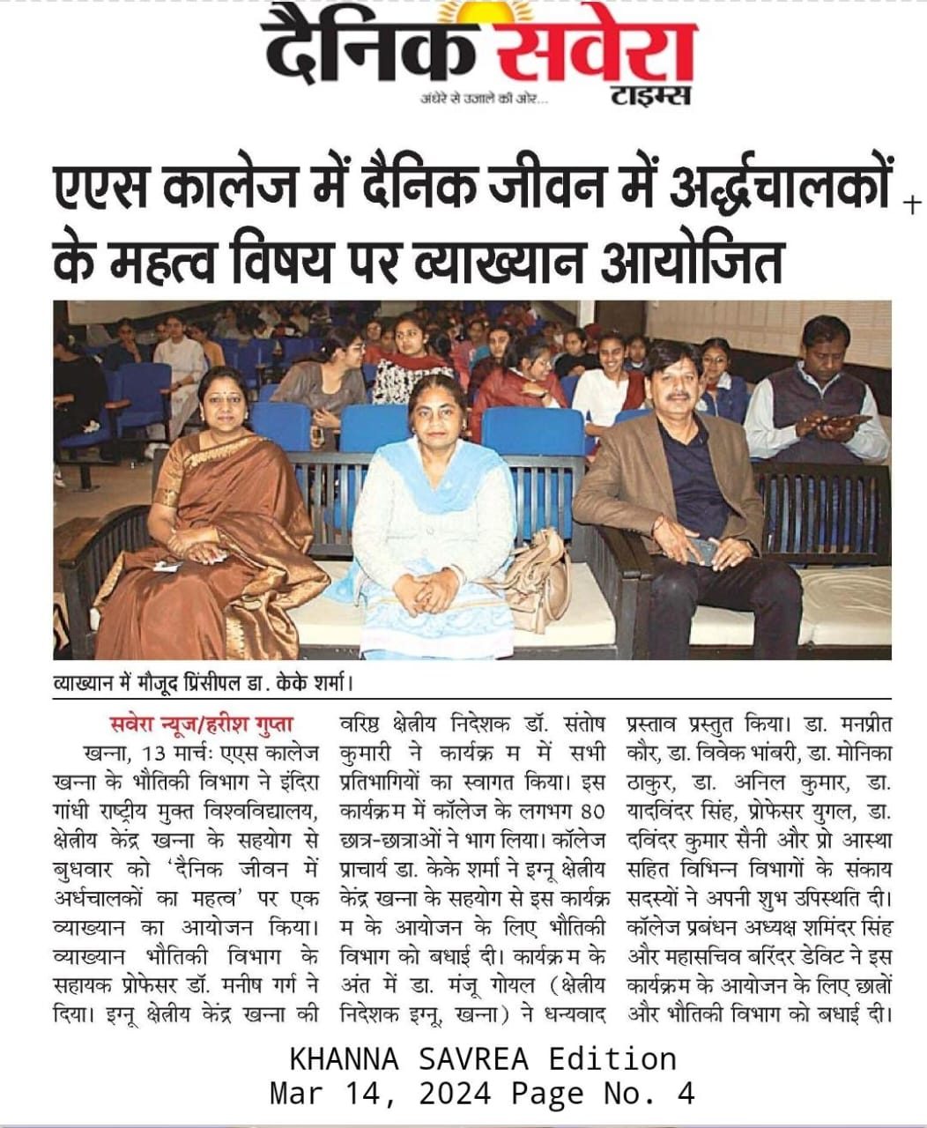
Achievements and List of Publications by the Faculty (2023-24)
Dr. Manish Garg
- Elected as a member of the Undergraduate Board of Studies in Physics, Panjab University Chandigarh for the session 2023-24.
- Nominated as a member of the Undergraduate Board of Studies in Physics, Mata Gujri College Fatehgarh Sahib for the term 2023-24.

Dr. Jasdeep Kaur
- Delivered an Expert talk on “Quantum Consciousness” on February 03, 2024 at S.C.D. Govt. College Ludhiana.

